Module 10 Assignment: GUI To-Do List
Name: Tara Rai
Course: M10
Date: 02/27/2026

Base Code (PDF)

import tkinter as tk
from tkinter import Menu

def open_file():
print("File > Open command clicked")

def save_file():
print("File > Save command clicked")

def cut_text():
print("Edit > Cut command clicked")

def copy_text():
print("Edit > Copy command clicked")

def paste_text():
print("Edit > Paste command clicked")

def about():
print("Help > About command clicked")

root = tk.Tk()
root.title("Menu Example")

menu_bar = Menu(root)
root.config(menu=menu_bar)

# File menu
file_menu = Menu(menu_bar, tearoff=0)
menu_bar.add_cascade(label="File", menu=file_menu)
file_menu.add_command(label="Open", command=open_file)
file_menu.add_command(label="Save", command=save_file)
file_menu.add_separator()
file_menu.add_command(label="Exit", command=root.destroy)

# Edit menu
edit_menu = Menu(menu_bar, tearoff=0)
menu_bar.add_cascade(label="Edit", menu=edit_menu)
edit_menu.add_command(label="Cut", command=cut_text)
edit_menu.add_command(label="Copy", command=copy_text)
edit_menu.add_command(label="Paste", command=paste_text)

# Help menu
help_menu = Menu(menu_bar, tearoff=0)
menu_bar.add_cascade(label="Help", menu=help_menu)
help_menu.add_command(label="About", command=about)

root.mainloop()

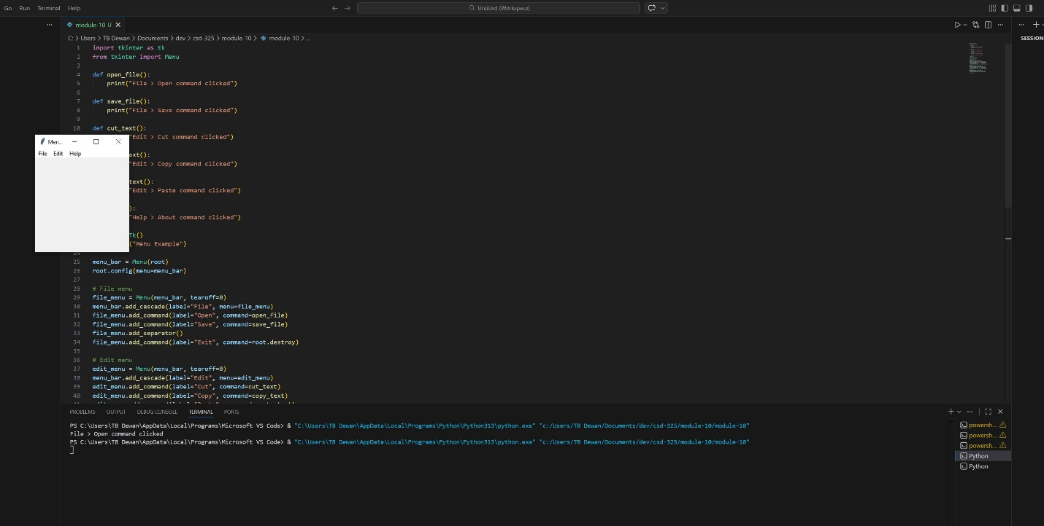
Result Todo base,
PS C:\Users\TB Dewan\AppData\Local\Programs\Microsoft VS Code> & "C:\Users\TB Dewan\AppData\Local\Programs\Python\Python313\python.exe" "c:/Users/TB Dewan/Documents/dev/csd-325/module-10/todo_base.py"

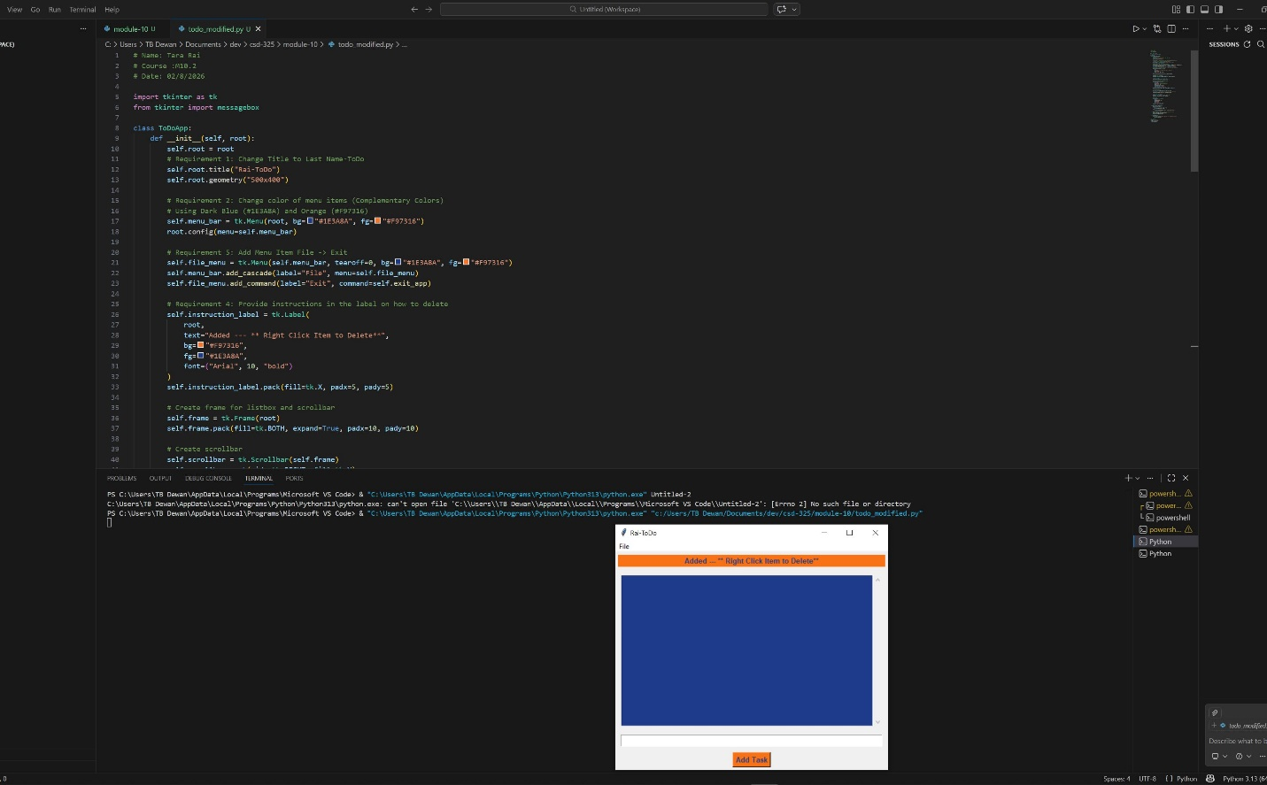
Todo modified

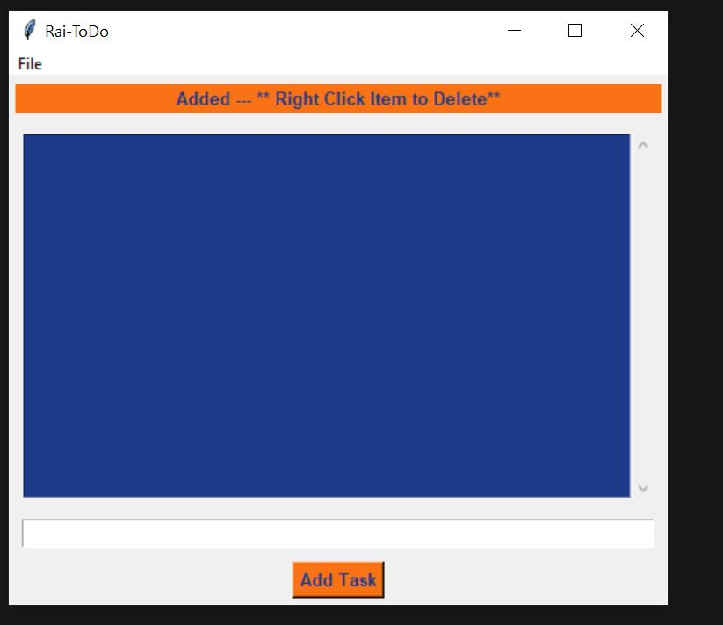
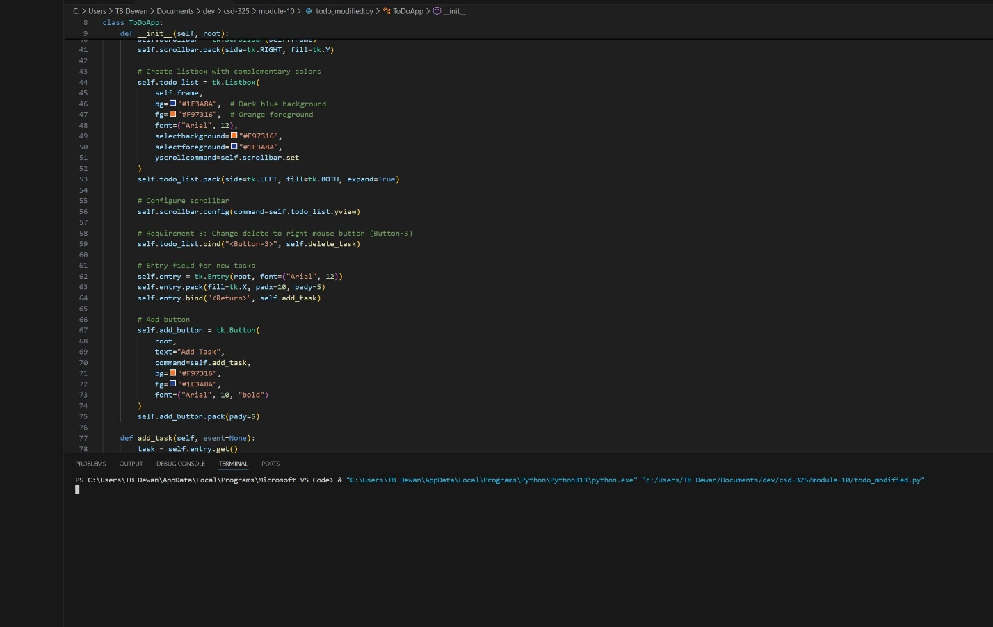

PS C:\Users\TB Dewan\AppData\Local\Programs\Microsoft VS Code> & "C:\Users\TB Dewan\AppData\Local\Programs\Python\Python313\python.exe" "c:/Users/TB Dewan/Documents/dev/csd-325/module-10/todo_modified.py"

# Name: Tara Rai
# Course :M10.2
# Date: 02/8/2026

import tkinter as tk
from tkinter import messagebox

class ToDoApp:
def __init__(self, root):
self.root = root
# Requirement 1: Change Title to Last Name-ToDo
self.root.title("Rai-ToDo")
self.root.geometry("500x400")

# Requirement 2: Change color of menu items (Complementary Colors)
# Using Dark Blue (#1E3A8A) and Orange (#F97316)
self.menu_bar = tk.Menu(root, bg="#1E3A8A", fg="#F97316")
root.config(menu=self.menu_bar)

# Requirement 5: Add Menu Item File -> Exit
self.file_menu = tk.Menu(self.menu_bar, tearoff=0, bg="#1E3A8A", fg="#F97316")
self.menu_bar.add_cascade(label="File", menu=self.file_menu)
self.file_menu.add_command(label="Exit", command=self.exit_app)

# Requirement 4: Provide instructions in the label on how to delete
self.instruction_label = tk.Label(
root,
text="Added --- ** Right Click Item to Delete**",
bg="#F97316",
fg="#1E3A8A",
font=("Arial", 10, "bold")
)
self.instruction_label.pack(fill=tk.X, padx=5, pady=5)

# Create frame for listbox and scrollbar
self.frame = tk.Frame(root)
self.frame.pack(fill=tk.BOTH, expand=True, padx=10, pady=10)

# Create scrollbar
self.scrollbar = tk.Scrollbar(self.frame)
self.scrollbar.pack(side=tk.RIGHT, fill=tk.Y)

# Create listbox with complementary colors
self.todo_list = tk.Listbox(
self.frame,
bg="#1E3A8A", # Dark blue background
fg="#F97316", # Orange foreground
font=("Arial", 12),
selectbackground="#F97316",
selectforeground="#1E3A8A",
yscrollcommand=self.scrollbar.set
)
self.todo_list.pack(side=tk.LEFT, fill=tk.BOTH, expand=True)

# Configure scrollbar
self.scrollbar.config(command=self.todo_list.yview)

# Requirement 3: Change delete to right mouse button (Button-3)
self.todo_list.bind("<Button-3>", self.delete_task)

# Entry field for new tasks
self.entry = tk.Entry(root, font=("Arial", 12))
self.entry.pack(fill=tk.X, padx=10, pady=5)
self.entry.bind("<Return>", self.add_task)

# Add button
self.add_button = tk.Button(
root,
text="Add Task",
command=self.add_task,
bg="#F97316",
fg="#1E3A8A",
font=("Arial", 10, "bold")
)
self.add_button.pack(pady=5)

def add_task(self, event=None):
task = self.entry.get()
if task:
self.todo_list.insert(tk.END, task)
self.entry.delete(0, tk.END)
else:
messagebox.showwarning("Warning", "Please enter a task!")

def delete_task(self, event):
# Get the index of the item clicked with right mouse button
index = self.todo_list.nearest(event.y)
self.todo_list.delete(index)

def exit_app(self):
# Confirm exit
if messagebox.askyesno("Exit", "Are you sure you want to exit?"):
self.root.destroy()

# Main program
if __name__ == "__main__":
root = tk.Tk()
app = ToDoApp(root)
root.mainloop()

